Lab:11 Write a menu-based program to Multicast and Broadcast messages using client-server

Ans:

Source code:

Server:

import socket

HOST = '127.0.0.1'

PORT = 3300

conn_list = list()

with socket.socket(socket.AF_INET, socket.SOCK_STREAM) as s:

s.bind((HOST,PORT))

s.listen()

while True:

choice = int(input("Enter\n 1. to add network\n 2. to send message to all connections\n 4. to end\n"))

if(choice==1):

conn,add = s.accept()

conn_list.append((conn,add))

conn.sendall(b'connected to Server')

print("Connected to:" + add[0]+":"+str(add[1]))

elif(choice==2):

msg:str = input("Enter message to send: ")

for c,a in conn_list:

c.sendall(msg.encode())

else:

break

Client:

import socket

HOST:str='127.0.0.1'

PORT:int=3300

with socket.socket(socket.AF_INET,socket.SOCK_STREAM) as s:

s.connect((HOST,PORT))

while True:

data=s.recv(1024)

if not data or data.decode()=="bye":

break

print("Server: " +data.decode())

Output:

server:

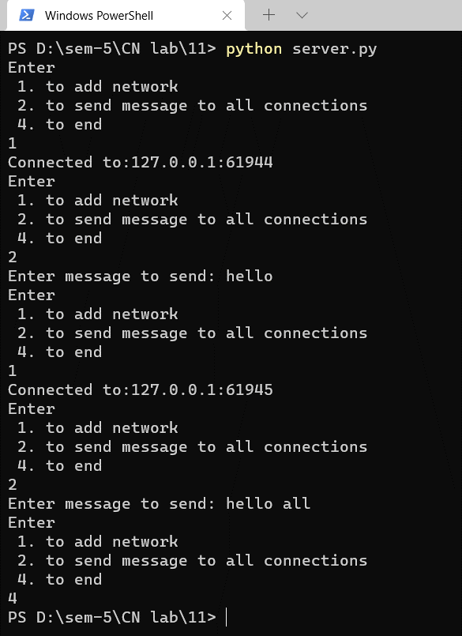

Client:

